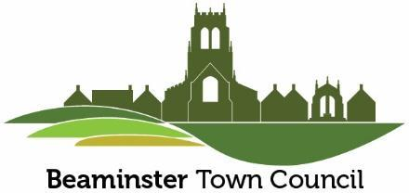

Minutes of a meeting of Beaminster Town Council’s Community Engagement Committee held in the Cowie Room, Public Hall on Thursday 26th June 2025 commencing at 7.00pm

**207 PRESENT**

Cllr Biggs, Cllr Corbett, Cllr Gillings, Cllr Gunning, Cllr Tuff and Cllr Watts; also Christine Bright (Town Clerk).

1. **APOLOGIES FOR ABSENCE**

Apologies were received from Cllr Turner and Cllr Woods; also Ethan Kalemjian (Administrator)

1. **ELECTION OF CHAIRMAN**

Cllr Gunning proposed Cllr Corbett, seconded by Cllr Biggs, there being no other nominations Cllr Corbett was duly elected Chairman for the ensuing Council year.

**210 ELECTION OF VICE CHAIRMAN**

Cllr Corbett proposed Cllr Biggs, seconded by Cllr Gunning, there being no other nominations Cllr Biggs was duly elected Vice Chairman for the ensuing council year.

**211 DECLARATIONS OF INTEREST & DISPENSATIONS**

No interests were declared.

**212 MINUTES OF THE PREVIOUS MEETING**

The minutes of the Community Engagement Committee meeting held on 22nd May 2025, having previously been circulated were signed by the Chairman as an accurate record.

**213 VJ-DAY ANNIVERSARY COMMEMMORATION**

Members **NOTED** the detail of the time table put together by the Royal British Legion for a small

commemorative event in the Square on Friday 15th August at 7.00pm. An invitation would be

extended to local organisations to participate in the ceremony however there would not be a

formal parade. There were also no plans to light a beacon.

Cllr Biggs sought clarification as to whether a road closure application would be required, this would be pursued with Dorset Council. He advised that barriers were available and sought assistance from members with regard to traffic control.

**214 SCARECROW TRAIL**

Cllr Biggsfelt that it was essential to reach out to local businesses and organisations with a view to

compiling the trail as soon as possible. He also outlined his thoughts on extending the event to include ‘Best Scarecrow’ Competition with official judging in the Memorial Playing Field possibly in conjunction with another event.

Page 18

The Town Clerk confirmed plans for the event had been discussed within the office and were in hand. With regard to the suggestion of a ‘Best Scarecrow’ Competition the Town Clerk advised of the limited budget for this event had been intended for prizes in connection with the scarecrow trail. Cllr Biggs confirmed sponsorship for the Competition had been obtained.

**215 DATE OF NEXT MEETING**

The date of the next meeting was **NOTED** as Thursday 24th July 2025.

**216 MEETING**

The meeting which commenced at 7.00pm concluded at 7.58pm.

Chairman

24th July 2025

Page 19